# Survival analysis - Overview

1. What is survival analysis?

* Also known as **time-to-event analysis**
* A branch of statistics that studies the amount of time it takes before a particular event of interest occurs
* Applications: Insurance companies – predict the death of the insured and estimate other important factors (e.g., policy cancellations, non-renewals), and how long it takes to file a claim -> calculate insurance premiums, lifetime value of customers
* Initially developed in biomedical sciences to understand the onset of certain diseases – now used in engineering, insurance, etc.

1. Understanding survival analysis

* Mainly comes from the medical and biological disciplines – study rates of death, organ failure, onset of diseases
* Can also apply to positive events (e.g., how long it might take someone to win the lottery if they play it every week)
* Adapted to biotechnology sector, economics, marketing, machine maintenance, engineering, etc.
* Uses the **hazard rate** to measure the odds / chances of an item or system failing – dependent upon the amount of time the item / system has been in use
* Survival analysis in insurance:
* Use to outline the incidence of death at different ages given certain health conditions
* Compute the prob of whether policyholders will outlive their life insurance coverage
* Providers can calculate an appropriate insurance premium (the amount each client is charged for protection) by also taking into account thee value of the potential customer payouts under the policy
* E.g.: estimate how long it will take drivers from a particular zip code to have an auto accident, based on location, age, type of insurance, time since last claim filed

1. Advantages & disadvantages

* Other more common statistical methods: regression analysis – commonly used to determine how specific factors influence the price movement of an asset
* Problem: linear regression often makes use of both positive and negative numbers
* **Survival analysis deals with time, which is strictly positive**
* Linear regression is not able to account for censoring – survival data that is not complete for various reasons (**right-censoring** – the subject has not yet experienced the expected event during the studied time period)
* Main benefit of survival analysis: better tackle the issue of censoring – main variable, other than time, addresses **whether the expected event happened** or not

# Survival Analysis Part I: Basic concepts and first analyses

1. Introduction

* Cancer studies: Main outcome under assessment – time to an event of interest (survival time)
* It is usual that at the end of follow-up, some of the individuals have not had the event of interest -> true time to event is unknown
* Survival data – rarely normally distributed – skewed & comprise typically of many early events and relatively few late ones
* Survival analysis necessary
* Most survival analyses in cancer use some or all: Kaplan-Meier plots, logrank tests, Cox (proportional hazards) regression

1. Types of ‘event’ in cancer studies

* Medical studies**: time to death** is the event of interest
* However, in cancer, another important measure: **time between response to treatment** and recurrence or **relapse-free survival time** (disease-free survival time)
* What the event is & when the period of observation start & finishes
* E.g.,: relapse in the time period between a confirmed response and the first relapse of cancer

1. Censoring

* Specific difficulties of survival analysis: only some individuals have experienced the event and survival times will be unknown for a subset of the study group
* Censoring, may arise in the following ways:
* A patient has not (yet) experienced the relevant outcome (e.g., relapse or death) by the time of the close of the study
* A patient is lost to follow-up during the study period
* A patient experiences a different event that makes further follow-up impossible
* **Right-censoring**: The event (assuming it occurs) **is beyond the end of the follow-up** period
* **Left-censoring** can also occur if we observe the presence of a state or condition but **do not know where it began**
* **Interval censor**: individuals come in and out of observation
* The feature of censoring means that special methods of analysis are needed

1. Survival and hazard

* Survival data generally described and modelled in terms of **2 related probabilities: survival and hazard**
* **Survival probability (survival function) - S(t)**: the probability that an individual survives from the time origin (e.g., diagnosis of cancer) to a specified future time t.
* Survival prob for different values of t provide crucial summary info from time to event data
* Describe directly survival experience of a study cohort
* Focuses on **not having an event**
* **Hazard – h(t) or λ(t):** the probability that an individual who is under observation at a time t has an event at that time
* Instantaneous event rate for an individual who has already survived to time t
* Focuses on the **event occurring**
* Insight into the conditional failure rates -> help specifying a survival model
* Hazard relates to the incident (current) event rate, while survival reflect the cumulative non-occurrence

1. Kaplan-Meier survival estimate

* Survival prob can be estimated nonparametrically from observed survival times, both censored and uncensored, using the KM (product-limit) method (Kaplan and Meier, 1958)
* Suppose k patients have events in the period of follow-up at distinct times
* Events are assumed to **occur independently** of one another
* The prob of **surviving from one interval to the next** may be **multiplied** together to give the **cumulative survival prob**
* **The prob of being alive at time**  is calculated by:

Where:

* : prob of being alive at time
* : number of patients alive just before
* : number of events at
* S(0) = 1
* **is constant between times of events**, and therefore the estimated prob is a step function that changes value only at the time of each event
* This estimator allows each patient to contribute info to the calculations for as long as they are known to be event-free
* In case of no censoring (i.e., every individual is to experience the event), this estimator would simply reduce to the ratio of the number of individuals event-free at time t divided by the number of people entering the study
* **Cumulative incidence at a time point** = 1 – survival prob.
* Confidence intervals for the survival prob:
* The KM survival curve, a plot of KM survival prob against time provides a useful summary of the data that can be used to estimate measures such as median survival time (large skew in distribution of most survival data -> mean is not often used)
* In practice, there are usually patients who are lost to follow-up or alive at the end of follow-up, and confidence limits are often wide at the tail of the curve, making meaningful interpretations difficult
* E.g.:

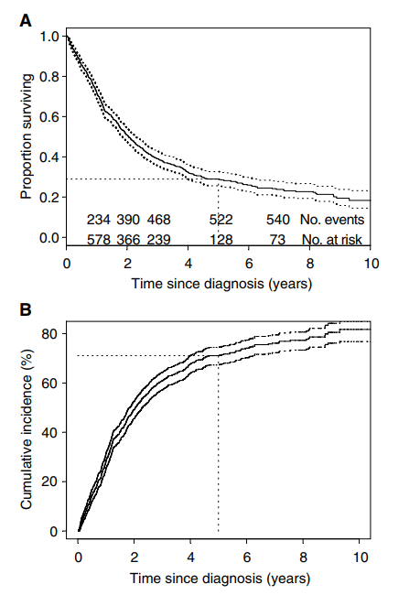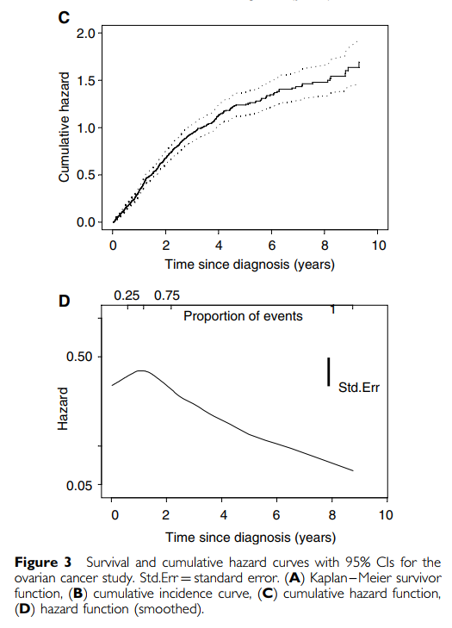

1. **Hazard and cumulative hazard**

* Relationship between
* Unimportant for routine survival analyses as it is incorporated into most statistical computer packages
* If either S(t) or h(t) is known, the other is automatically determined >< Unlike S(t), there is no simple way to estimate h(t)
* Instead, a quantity called the **cumulative hazard**  is commonly used, defined as the **integral of the hazard**, or the area under the hazard function between times 0 and t, and differs from the log-survivor curve only be sign, i.e.,
* **Interpretation of :** cumulative force of mortality, or the number of events that would be expected for each individual by time t if the event were a repeatable process
* is used as an intermediary measure for estimating and as a diagnostic tool in assessing model validity
* Nonparametric method for estimating : Nelson-Aalen estimator, from which it is possible to derive an estimate of by applying a kernel smoother to the increments. Cox (1979) – another method to estimate the hazard based on order statistics but similar in spirit to the previous method
* Another approach for estimating hazard: assume that the survival times follow a specific mathematical distribution
* Constant hazard rate over time (analogous to exponential distribution of survival times)
* Strictly increasing / decreasing hazard rates based on a Weibull model
* Combination of decreasing and increasing hazard rates using a log-normal model

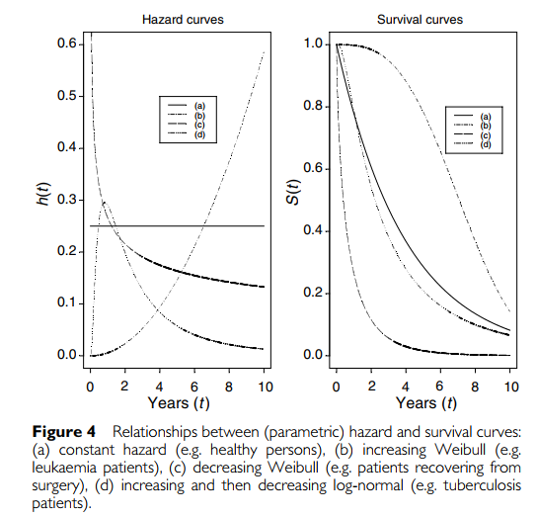

1. Nonparametric tests comparing survival

* **Compare survival in 2 or more groups** of patients - logrank test (Peto et al, 1977)
* The method calculates **at each event time, for each group, the number of events one would expect** since the previous event if there were **no difference between the groups.** Values are then summed over all event times to give the **total expected number of events in each group**, say
* The logrank test **compares the observed number of events**, say for treatment group i, **to the expected number** by calculating the test statistic
* This value is **compared to a distribution** with (g-1) degrees of freedom, where g is the number of groups
* **P-value** may be computed to calculate the statistical significance of the differences between the complete survival curves
* If the groups are **naturally ordered** -> consider the possibility that there is a **trend in survival** across them, for example, age groups or stages of cancer
* Calculating and for each group on the basis that survival may increase or decrease across the groups -> more powerful test
* For the new and , the test statistic for trend is compared with distribution with one degree of freedom
* **Only 2 groups**: logrank test is testing the **null hypothesis that the ratio of the hazard rates in the 2 groups = 1**
* **Hazard ratio (HR)** – measure of the relative survival experience in the 2 groups and may be estimated by

Where is the estimated relative (excess) hazard in each group i.

* Confidence interval for HR
* HR has similar interpretation of the strength of effect as a risk ratio
* HR = 1 -> no difference in survival
* In practice, better to estimate HRs using a regression modeling technique, using Cox regression

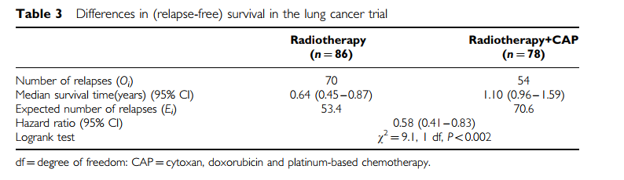

* Other nonparametric tests include methods to compare median survival times, but comparing confidence intervals for each group is not recommended (Altman and Bland, 2003).

1. Some key requirements for the analysis of survival data

* **Uninformative censoring**
* Standard methods to analyze survival data with censored observations are **valid only if the censoring is ‘noninformative’** -> censoring carries no prognostic info about subsequent survival experience. Those who are censored because of loss to follow-up at a given point in time should be as likely to have a subsequent event as those individuals who remain in the study.
* However, when the number of patients lost to follow-up is small, very little bias is likely to result from applying methods based on noninformative censoring
* **Length of follow-up**
* Time to event studies must have **sufficient follow-up to capture enough events** -> sufficient power to perform appropriate statistical test
* Proposed length of follow-up – based primarily on the severity of the disease or prognosis of participants
* E.g.,: lung cancer trial – 5-year follow up; breast cancer patients – need longer follow-up duration
* An indicator of length of follow-up – median follow-up time, calculated from follow-up among the individuals with censored data
* Reverse KM estimator – more robust measure: Event indicator reversed so that the outcome of interest becomes being censored
* **Completeness of follow-up**
* Unequal follow-up between different groups (e.g., treatment arms) may bias the analysis
* **Disparities in follow-up** caused by differential drop-out between arms of a trial or different subgroups in a cohort study need to be investigated
* **Cohort effect on survival**
* Assumption of **homogeneity of treatment and other factors during the follow-up period** >< in a long-term observational study of patients of cancer, the case mix may change over the period of recruitment, or there may be an innovation in ancillary treatment.
* KM method assumes that the **survival prob are the same for subjects recruited early and late** in the study
* Between-center differences
* Consistency between the study methods in each center

1. Need for survival analysis adjusting for covariates

* When comparing treatments in terms of survival, it is often sensible to adjust for patient-related factors (covariates or confounders), which could potentially affect the survival time of a patient
* E.g., suppose that despite the treatment being randomized in the lung cancer trial, older patients were assigned more often to the radiotherapy alone group -> this group will have worse baseline prognosis -> underestimated efficacy compared to the combination treatment
* Confounding between treatment and age
* Sometimes, we want to determine the prognostic ability of various factors on overall survival
* Multiple prognostic factors can be adjusted for using multivariate modeling

1. Summary

* Survival analysis: a collection of statistical procedures for data analysis where the outcome variable of interest is time until an event occurs
* Censoring -> a proportion of survival times of interest will often be unknown
* Assumption: patients who are censored have the same survival prospects as those who continue to be followed -> uninformative censoring
* Survival data – generally described and modeled in terms of 2 related functions – survival function & hazard function
* Survivor function – prob that an individual survives from the time of origin to some time beyond time t
  + directly describes the survival exp of a study cohort
  + usually estimated by the KM method
  + test for differences between survival curves for groups – logrank test
* Hazard function – instantaneous potential of having an event at a time, given survival up to that time
  + Used primarily as a diagnostic tool or for specifying a mathematical model for survival analysis
* In comparing treatments or prognostic groups in terms of survival, necessary to adjust for patient-related factors that could potentially affect the survival time of a patient
* Multivariate survival analysis (a form of multiple regression) provides a way of doing this adjustment

# Survival analysis part II: Multivariate data analysis – Intro to concepts and methods

1. The need for multivariate statistical modeling

* Previous paper: construction of survival curves for different patient groups (KM), and logrank test to investigate differences between them
* Univariate analysis – survival wrt factor under investigation, ignoring impact of others
* In clinical investigations, common to have a situation where several (known) quantities or covariates, affect the patient prognosis (e.g., genotype, age)
* Desirable to adjust for the impact of others
* Logrank test – provides p-value for the differences between the groups >< no estimate of the actual effect size (not a clinical assessment of the factor’s impact)
* Statistical model – improves on these methods by allowing survival to be assessed **with respect to several factors simultaneously** and offers **estimates of the strength of effect for each constituent** factor
* **Assumptions**:
* Survival times are independent of each other
* Censoring occurs solely as right-censoring
* Censoring are uninformative
* Focus on covariates measured at the time of entry to the study:
* Continuous (e.g. age, tumor size)
* Binary (e.g., gender)
* Unordered categorical (e.g., histology)
* Ordered categorical / ordinal (e.g., performance status, FIGO stage)
* Methods – 2 broad categories:
* Proportional hazard approaches (incl. semi-parametric Cox model and fully parametric approaches)
* Accelerated failure time models

1. **Cox (semi-parametric) proportional hazards model**

* Most commonly used multivariate approach for analyzing survival time data in medical research
* Survival analysis regression model
* Describes the relation between the event incidence, as **expressed by the hazard function and a set of covariates**
* The hazard function is dependent on a set of p covariates , whose impact is measured by the size of the respective coefficients
* The term - baseline hazard: value of the hazard if all the = 0
* **Hazard may vary over time**
* The baseline hazard function is estimated nonparametrically -> survival times are **not assumed to follow a particular statistical distribution**
* Essentially a **multiple linear regression of the logarithm of the hazard** on the variables , with the baseline hazard being an ‘intercept’ term that varies with time
* Covariates act multiplicatively on the hazard at any point in time
* **Key assumption of the PH model**: the hazard of the event in any group is a constant multiple of the hazard in any other
* The hazard curves for the groups should be proportional and cannot cross

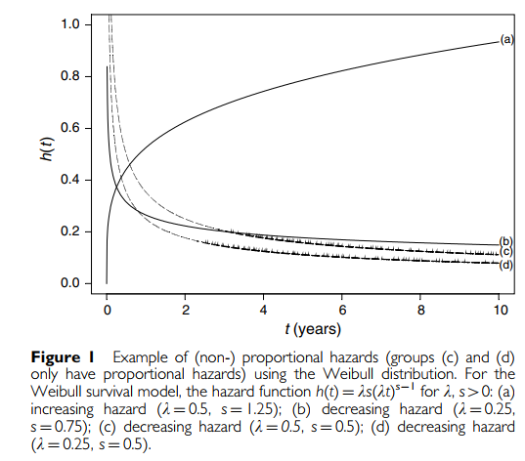

* **Proportionality** implies that the quantities are called hazard ratios
* **Hazard ratio > 1** -> covariate positively associated with the event prob & negatively associated with the length of survival
* Proportionality assumption is often appropriate for survival time data but it is important to verify that it holds
* Example: Cox PH model fitted to ovarian cancer data

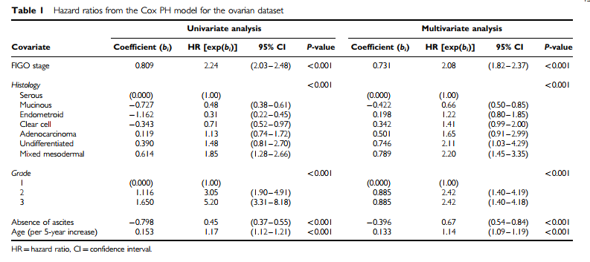

1. **Parametric PH model**

* A class of models **similar in concept and interpretation** to the Cox PH model
* Key difference: the **hazard is assumed to follow a specific statistical distribution** when a fully parametric PH model is fitted to the data
* Hazard ratios have the same interpretation, whether derived from a Cox or a fully parametric regression model
* Proportionality of hazards is still assumed
* Choosing **different hazard functions -> different parametric PH models**
* The choice of hazard distribution determines that of the survival
* Models commonly applied (e.g., **Exponential, Weibull, Gompertz**) take their names from the distribution that the survival times are assumed to follow
* Most distinguishing features between them are in the hazard function
* E.g.: Parametric models fitted to the ovarian cancer data

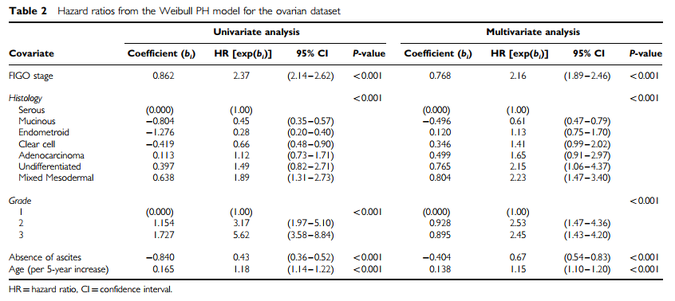

1. **Comparison of the two PH approaches**

* **Parametric models** – main drawback: need to **specify the distribution** that most appropriately mirrors actual **survivor times**
* May be difficult to identify
* In case a suitable distribution is found, parametric model is more informative than Cox model
* Straightforward to derive the hazard function and obtain predicted survival times
* Slightly more efficient – more precise estimates (smaller standard errors)
* Results from Cox or parametric PH models may be compared directly
* For either method to be valid:
* **Covariate effect needs to be at least approx. constant** throughout the duration of the study
* **Proportionality assumption** must hold

1. **Interpreting the PH model: Beyond the hazard ratio**

* In addition to the ratio of two hazards, predicted survival proportion at any given point in time for a particular risk group can be derived.
* **Survival proportion for a given risk group at any time,** :

is the baseline survival (when all covariates = 0) and

* Baseline survival at a given time -> predicted survival prob for patients with any specified covariate values
* E.g.:

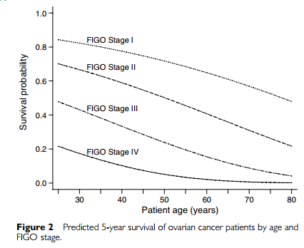

1. **Accelerated failure time models**

* A different type of model used for analysis of survival time data

Where is the baseline survivor function and  **is an ‘acceleration factor’** that depends on the covariates

* Principle: the effect of a covariate is to **stretch or shrink the survival curve along the time axis** by a constant relative amount

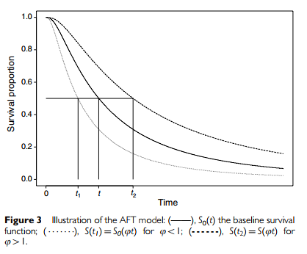

* **AFT model is commonly rewritten as being log-linear with respect to time**

Where is a measure of (residual) variability in the survival times.

* Survival times can be seen to be multiplied by a constant effect under this model specification, and the **exponentiated coef, , are referred to as time ratios**.
* Time ratio > 1 – ‘slows down’ or prolongs time to the event
* Time ratio < 1 – accelerates time to the event
* **Survival time follows a Weibull distribution** -> AFT and PH models are the same

>< AFT models differs from PH models in terms of their interpretation of effect sizes as time ratios as opposed to hazard ratios

* Other quantities (e.g., projected survival prob) may be derived
* **Assumptions**
* Appropriate choice of **statistical distribution of survival times** (e.g., log-normal, log-logistic, generalized gamma, Weibull) needs to be made
* **Covariates effects** are constant and multiplicative on the timescale (i.e., covariate impacts **on survival by a constant factor**)
* E.g.: Parametric AFT models fitted to the lung cancer trial data

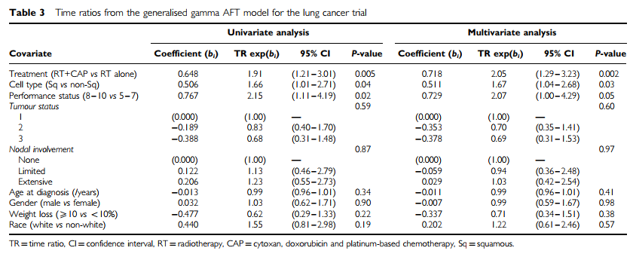

1. **Which model should we use: PH vs. AFT?**

* From statistical viewpoint, an obvious way to choose between the 2 model types is to fit a type that is in keeping with the data
* However, when either type of model may appear to fit the data adequately, the choice of model may be influenced by other factors
* E.g.: if other studies of a similar nature had all used Cox regression and reported results as hazard ratios, one may be tempted to follow suit to aid comparability
* Parametric approach offers more in the way of predictions
* AFT allows the derivation of a time ratio -> more interpretable than a ratio of 2 hazards >< unfamiliar in medical research

1. Other approaches

* **Stratified survival analysis**
* More straightforward way to incorporate covariates into a survival analysis
* E.g.: Suppose the covariate of primary interest is treatment but we wish to control for the clinical stage of the tumor when comparing
* Survival in each treatment group can be compared within each stage of disease (strata) by the logrank or some other methods
* Differences within each stratum are then combined to given an overall comparison of treatments that has been adjusted for the stage
* Strength: Simplicity – logrank test is nonparametric -> few distributional assumptions made + interpretation straightforward
* Limitation: only applicable when the covariate is categorical (or with continuous variables that have been arbitrarily categorized). Does not perform well with several covariates – number of individuals in each stratum quickly becomes too small for reasonable comparisons
* Does not quantify the strength of effect of each variable or even offer a p-value for factors other than the one of primary interest
* Not generally regarded as a formal statistical model
* Can be use where a very small number of covariates are to be considered, if only as an exploratory method of analysis
* **Aalen’s additive model**
* Assume that covariates impact additively upon a (unknown) baseline hazard, but the effects are not constrained to be constant, allowed to vary freely over time

where is the hazard, is the baseline hazard and the are coef (may change in magnitude and sign over time)

* Not straightforward to estimate nonparametrically -> Cumulative baseline hazard is used and the regression coef that are actually estimated from the data are also the cumulative (additional) hazard
* Representing the effect – graph against time
* The further is from 0 at time t, the greater the effect the covariate has had on the hazard over the course of the study up to t
* Values of – absolute increase in hazard at time t – are not actually observed, >< relative size may be inferred from the slope of the line
* Informal assessment of the adequacy of the proportional hazards assumption in the Cox model
* Lack easy interpretation - coef are not easy to understand, changing repeatedly overtime, offering no single quantifiable effect size
* Aalen plots are essentially the only manner with which to interpret the effect sizes
* Classification trees and artificial neural networks

1. Discussion

* Statistical models – ability to assess several covariates simultaneously
* Strengths of the stratified logrank rest and other such methods – simplicity & fewer parametric assumptions of the data
* Cox model – greater flexibility than parametric alternatives and does not require the direct estimation of the baseline hazard function (i.e., avoids the need to specify the distribution of survival times)

>< Proportionality assumption of hazard needs to be fulfilled for the results to be meaningful

* Other parametric models will produce more precise estimates where the distribution is specified correctly
* Further concern – choice of covariates to include (in next paper)

# Survival analysis part III: Multivariate data analysis – choosing a model and assessing its adequacy and fit

1. **Choice of covariates**

* **Sample size considerations**
* Implicitly assumed that subjects in a study are representative of a wider population
* Need to have data from an adequate number of subjects
* The power (and in some cases, validity) of a survival analysis is related to the **number of events** rather than the number of participants
* **At least 10 events need to be observed for each covariate** considered
* **Aim of study**
* Choice of covariates to include in the model depends on the study aims
* 3 possible scenarios:
* **Scenario 1**: **Single factor under investigation** for its association with survival, but several **other factors exist**
  + Rationale: **perform a specific test of one factor**
  + E.g., decide whether a new treatment prolongs survival, but also to adjust to prognostic factor that may or may not be equally matched between treatment groups
  + E.g., assess association between a market and patient survival
  + **Any terms that are of potential importance could be incorporated** whether significant or not, depending on the adequacy of the sample size
  + All of the covariates (excl. the one of primary interest) are **‘nuisance’ factors** considered only to ensure they have been taken due account for in assessing the importance of the factor under investigation
  + Less important covariates may be removed
* **Scenario 2**: **A collection of factors of known relevance** are under investigation for their ability to predict survival
  + Assess the **individual importance of a series of factors** and / or to attempt to build a model that helps **predict patient survival**
  + Simplest strategy: **model all covariates, obtain effect sizes -> how well the model predicts survival**
  + May be desirable to **remove factors from the model for simplicity**, provided predictive ability is not compromised
  + Assess the extent to which a covariate can predict survival – statistical significance is not enough
* **Scenario 3**: a collection of factors under investigation for potential association with survival, possibly with **additional known factors**
  + Exploratory in nature -> **identify quantities of potential importance** for further investigation
  + Often desirable to reduce number of covariates in the model by excl. those not statistically significant
  + Care must be exercised when several covariates are investigated as **false-positive rate (chance of finding a spurious effect) increases with each additional test**
* In practice, a study may combine all of the above types
* **Approaches to adding or removing covariates**
* Common choices focus on **‘semiautomated’ methods: stepwise selection**
* Models based purely on statistical significance may not be **clinically meaningful**
* Choice of covariates should be **verified by a degree of hands-on modeling**, where terms are **added or removed in a logical order** rather than solely according statistical significance
* Examples:

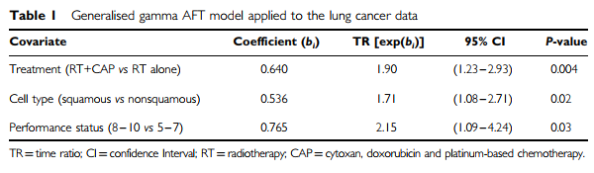

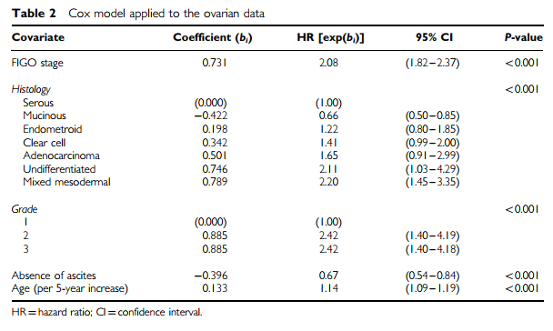

1. **Assessing the adequacy of a model**

* Important to evaluate how well the model represents the data
* A survival model is adequate when it represents the survival patterns in the data to an acceptable degree – goodness of fit
* **Adequacy of a model may be assessed in several ways**:
* Residuals from survival models
* Identifying the correct parametric model
* Overall goodness of fit tests
* **Residuals from survival models**
* Useful for checking the fit
* Large or systemic residuals -> poor model
* Several residuals proposed >< most are rather **difficult to understand due to censoring** -> Residuals are skewed and need to have smoothing functions (e.g., Kernel smoother) applied to aid interpretation
* Graphical displays should show **evenly scattered horizontal band & no obvious trend** (e.g., no slope)
* Overall model adequacy may be assessed by use of Cox-Snell residuals

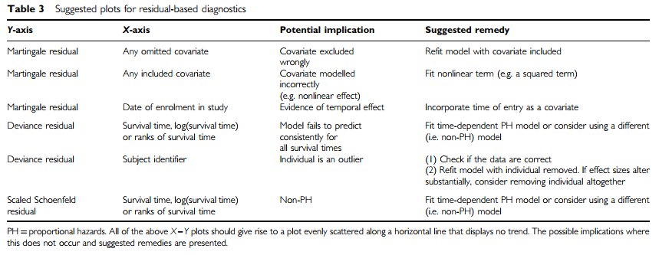

* **Identifying the correct parametric model**
* Most obvious distinguishing feature between parametric models – **shape of the hazard function**
  + Hazard always increase / decrease -> Weibull or Gompertz
  + Hazard rises to a peak then decrease / always decreases -> log-logistic
  + Hazard rises to a peak then decrease -> log-normal or generalized gamma
* Exponential model – hazard assumed to be constant over time
* **Actual shapes of these distributions depend on ancillary parameters** that are also estimated form the data

E.g., Weibull distribution – hazard function -> shape (s) and scale (λ) are ancillary parameters to be estimated

* If shape of hazard differs from a particular distribution -> should not analyze data with this parametric model (e.g., if hazard is rarely constant – can’t use exponential distribution; if hazard rises sharply before tailing off – can’t use Weibull)
* **Informal assessment of a parametric model’s** appropriateness may be made via:
  + **Plotting the (smoothed) empirical hazard or cumulative hazard** against those estimated by the model
  + **Log(-log(survival)) plots**
  + **Akaike’s Information Criterion (AIC)** – a statistic that trades off a model’s likelihood against its complexity -> **Lower AIC = better model**

where LL is the logarithm of the model likelihood (log-likelihood), c is number of covariates, s is the number of ancillary parameters (e.g., 2 in the case of Weibull) (Not possible to compare Cox PH models to fully parametric ones)

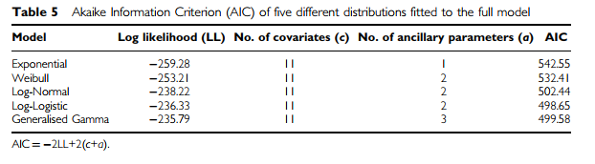

* It may be clear that **none of the parametric models adequately capture the distributional form** of the data -> **Cox model** is the obvious choice or parametric models in the **AFT framework** as they are more flexible
* **Overall goodness-of-fit tests**:
* Compare the **overall (Kaplan-Meier) survival curve** to the **model-based predicted survival**
  + Ideally, for any group of patients, the 2 should be close, if not identical
* Hosmer and Lemeshow (1999): compare **observed and expected events in different risk groups** as defined by the model
  + **Predicted risk or prognostic index (PI)** from a model consisting of covariates with estimated coef is:
  + PI calculated for each patient
  + Risk groups – constructed by categorizing the (ranked) PIs
  + A score test is then applied to the differences between observed and expected events in the risk groups
  + Adding the risk groups as a series of covariates to the survival model itself – significant improvement in the model likelihood -> the original covariates form an insufficient model for the data
* E.g.: Assessing overall goodness of fit on the ovarian cancer data
  + Several factors are associated with length of survival and some are also correlated with each other (e.g., histology & stage)
  + Predicted survival curves for each histological group may be estimated by fixing all other covariates at their mean values >< different estimated survival compared to those observed in the data (correlations are ignored)
  + Hosmer and Lemeshow (1999) test more useful
  + Patients split into 10 risk groups – proportion of deaths in each ranging from 10% to 94%
  + Approx. score test, derived from adding 9 covariates to the model, produced no evidence of a poor fit

1. **Assessing whether PH is appropriate**

* PH assumption: **hazards are proportional (and not overlapping) at all points in time** -> should be verified
* Plot the hazard in each group >< limited use
* Empirical hazard function is generally not well estimated -> **cumulative hazard generally preferred to assess the PH assumption**
* **Approach 1**: Plot of **logarithm of the cumulative hazard function** in each group against **logarithm of time**
* **Log(-log(survival)) plot** – cumulative hazard = negative logarithm of the survival proportion
* **Convergent or divergent lines** – lack of proportionality or omission of an important covariate -> **inadequate model**
* **Parallel lines** – models assuming **PHs may be suitable**
* **Approach 2: Statistical tests** for assessment of proportionality of hazard
* **(weighted) scaled Schoenfeld residual test** – test for an association between residuals and time (evidence of which indicates a bad fit)
* **Linear correlation test** – test for an association between residuals and time (evidence of which indicates a bad fit)
* **Time-dependent covariate test** – whether the effect (coef) of a covariate changes with time (i.e., nonconstant hazard ratio) -> detects nonproportionality & allows it to be modelled validly
* **Approach 3: Fit a stratified model** – a covariate that displays nonproportionality is modeled without the constraint of proportionality
* Covariate must be categorical (categorized)
* Covariate has no estimated effect size provided when forming the strata of a stratified model
* Suitable only for covariates not of primary interest
* **Approach 4: abandoning PH** in favor of some other model
* E.g.: Assessing the appropriateness of PH for the ovarian cancer data
* Kaplan-Meier survival curves and log(-log(survival)) vs log(time) plots for FIGO stage and histology
* Log(-log(survival)) plot for FIGO stage – reasonably parallel lines -> proportionality
* Log(-log(survival)) plot for Histology -> proportionality assumption appears to be violated
* (weighted) scaled Schoenfeld residuals test – significant overall nonproportionality (P = 0.05), as did the time-dependent covariate tests
* Assumption of proportionality violated
* Nevertheless, **Cox PH model can still be used with time-dependent covariates implemented**
* Include **interaction terms between the covariates and (log) time**
* Allows the effect of the relevant covariates to change with time
* Time-dependent terms suggest that the absence of ascites and endometroid histology have diminishing effects over time (hazard ratio tend towards 1)

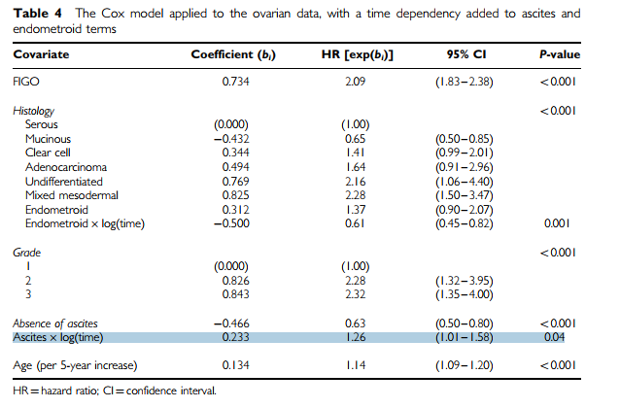

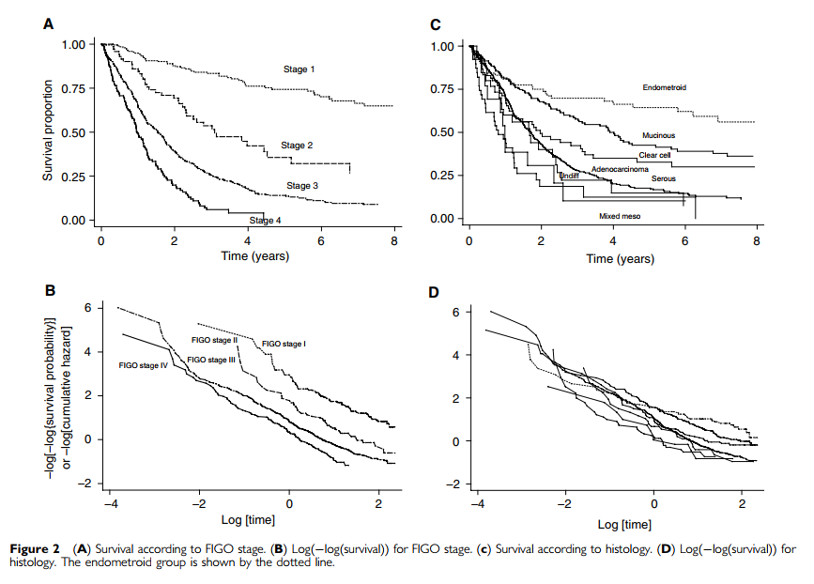

1. **Assessing whether an AFT model is adequate**

* Survival proportion in one group at any time t = survival proportion in the second at time where
* **Quantile – Quantile (Q-Q) plot of the times of survival percentiles** should lie on a straight line of slope that passes through (0, 0) -> useful but limited approach: departures from linearity could be due to the AFT model being inappropriate or that one or more important covariates have been omitted
* Methods of **stratification** or **modeling with time-dependent covariates** above may be applied as well
* E.g.: Lung cancer trial data
* Assess adequacy of Generalized Gamma and 4 other parametric models (AIC in Table 5 above) -> Generalized Gamma model has lower AIC – most accurate
* Check for excluded covariates: Martingale residuals plotted against potential model terms as before
* Predicted observed survival curves together with the predicted survival under a Generalized Gamma model

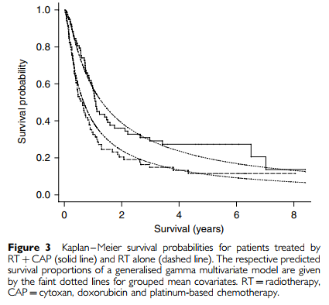

* Survival times for the 10th, 20th, … 90th survival percentiles for each treatment group plotted as a Q-Q plot – fit adequately

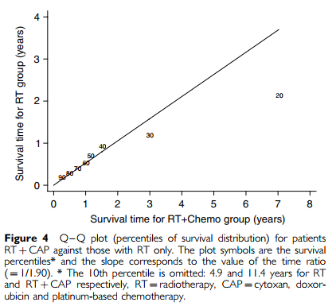

1. **Discussion**

* Why the model should be fitted? – First step
* Possible to choose a model from a purely statistical POV (e.g., goodness of fit measure), nonstatistical considerations should be taken into account
* Choice of model and covariates should be suggested from experience and based on specific question under investigation
* Diagnostics (e.g., residuals) for the different models may be difficult to interpret, but they will give an indication of whether modelling assumptions hold and ultimately, should be considered when model building

# Survival analysis Part IV: Further concepts and methods

1. **Continuous variables are sometimes categorized – should we do this?**

* No statistical reason for grouping and it can lead to as many problems as it seeks to avoid
* Categorization of a continuous covariate discards data -> introducing **measurement error**
* Leads to **biased estimates** and a reduced ability to detect real relationships
* There are sometimes **good reasons to categorize a continuous covariate**:
* Use **predetermined cut-points** (common choice: fixed centiles, established cut-points that have clinical meaning)
* **Do not choose cut-points based on minimizing p-values** -> biased results
* if possible, **use more than 2 categories** to reduce thee loss of information and allow some assessment of the linearity of any trend
* Ensure **each group contains an adequate number** of individuals and events
* Simplest approach: evaluate effect of **adding a quadratic term** to the model
* Better approach: use **smoothing spline**s or **fractional polynomials**

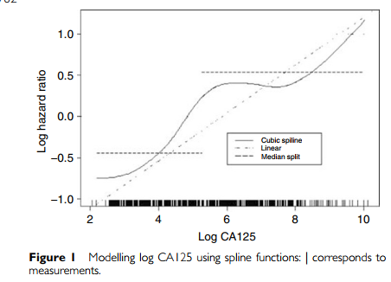

1. **Can we include multiple measurements for the same covariate in our survival analysis?**

* If **variables measured after entry** to the study -> special methods required
* **Time-dependent covariate methods** (variables may change value over time)
* Important to note that **post-entry measurements cannot be validly incorporated into a survival model without using these methods**
* Recall, for proportional hazard model, the formula relating a covariate to hazard

where is the baseline hazard.

**If repeated measurements of a covariate are taken, formula changes to:**

where is value of at time t. -> possible to use but harder to interpret

Note: **different from models with time-dependent coefficients** in which effect of a covariate changes, that is

* Time-dependent method can be applied >< **requires a large amount of data** -> rarely seen
* Ensure that **collection process is not itself dependent on clinical progress** (by using scheduled assessments)

1. **What is the censoring is informative?**

* **Informative censoring** – when individuals are lost to follow-up for reasons that may relate to their (unknown) outcome
* Introduces bias into the standard methods
* Difficult to identify informative censoring and assess its impact
* Helpful to know what proportion of censored individuals were lost to follow-up before the end of the study
* **Ad hoc approach: Sensitivity analyses** to assess the **impact of** **assigning different survival times** to those patients whose observed survival times may have been affected in this manner
* E.g.: if a patient suspected to be in ill health exits the study at 4 weeks:
  + First analysis: patient censored at 4 weeks
  + Second analysis: patient assumed to have relapsed at 4 weeks
* (i.e., **best case – worst case scenario**)
* Works best when there are few such patients – bias will be very small
* **Another approach: Decide a priori** that all such patients will be treated in a particular way
* **More formal approaches**: assume that **relationship exists between censoring times and baseline covariates** and perhaps also **post-treatment patient data** >< difficult to evaluate assumptions and limited implementation
* If follow-up stops because the patient experienced a **different defined event** -> **competing risk scenario** or handled via a **mixture model (‘cure’ model)** where the differing event types are explicitly modelled
* In practice, if there is **little informative censoring -> minimal bias**
* Using these along with simply reporting loss to follow-up (and a basic sensitivity analysis) will suffice

1. **Some covariate data are missing**

* Unless only a few values are missing, some investigation of missing data and methods that accommodate it should be considered
* **Imputation methods**: missing data are imputed or replaced with a set of plausible values

1. **How should we choose which variables to include in the survival model?**

* As a starting point, it is good practice to include **known prognostic factors** and any that are **specifically required** by the study aims
* Then, consider new factors that **add significant additional predictive ability**
* Large number of factors of interest & little info about their prognostic influence -> **automated selection techniques** (e.g., stepwise methods: backward/forward)
* Disadvantage: only evaluate a small number of the set of possible models
* Each **possible model** could be fitted -> **best picked on the basis of a goodness-of-fit measure** (e.g., Mallow’s C)
* May be time-consuming with many covariates
* All these methods are problematic: ‘best’ model is derived solely on statistical grounds (may lack clinical meaning)
* Regression coef produced are biased (too large)
* Standard errors and p-values are too small, esp. for smaller sample sizes and when few events occur
* **Backward elimination** is possibly the best of the above methods
* **Alternative: Lasso method** – force some regression coef estimates to be exactly 0 -> achieving variable selection while shrinking remaining coef toward 0 to reflect overfitting and overestimation caused by data-based model selection

1. **Measure predictive ability? Validation?**

* To be of use, the model must be able to:
* Make unbiased predictions – give predicted prob that match closely those observed
* Distinguish higher and lower risk patients
* 2 components of predictive ability**: calibration and discrimination**
* Models rarely perform as well on either basis when used to predict survival in patients other than those used to derive the model
* **Internal validity** -> model that closely mirrors the survival patterns of the present data
* **External validity** -> should do so for other groups of patients as well
* Before applied in clinical practice, should have been shown to meet both criteria
* **Measures of discrimination**
* **C-index**: a generalization of the area under the receiver operation characteristic (ROC) curve – prob of concordance between observed and predicted survival based on pairs of individual
* **Nagelkerke’s**
* **Measures of calibration:**
* **Estimate of slope shrinkage**
* Evaluated for the data used in the modelling by splitting into train and validate sample
* Proportion of data to include in each sample is arbitrary
* Bootstrapping, ‘leave-one out’ cross-validation
* Alternative: estimate shrinkage factors and apply these to regression coef to counter overoptimism
* Internal validity established -> test for generalizability -> assess adequacy

1. **Can we perform an analysis where there are unmeasured factors that may affect survival time?**

* When a **strongly prognostic var is omitted, the model may be biased**: estimated treatment effect in a randomized trial may be biased if an important prognostic var is not adjusted for, event when that var is balanced between the treatment groups
* Inappropriate to proceed at all
* When **some individuals have a shared exposure** that is unmeasured (e.g., members of the same family have shared dietary and other environmental exposures -> their outcomes cannot be considered to be independent)
* ‘multilevel’ data – variation both between and within groups
* Random effects (or ‘frailty’) models can be used to allow covariate effects to vary across groups
* Lack of fit of a Cox model may be better explained by other modelling approaches, such as the AFT model

1. **Artificial neural networks**

* **Artificial neural networks**
* Key feature of ANN methodology: assume that there are **some latent, or ‘hidden’, intermediary variables** in the input and output processes
* **Covariates do not act directly on the response variable, but channel their influence into a series of latent variables**
* The **relative importance of these unobservable variables** which determines the survival
* Can incorporate complex relationships between covariates and survival more easily than standard approaches
* However, criticisms include:
  + High chance of overfitting
  + Lack of easy interpretation of the model and of the impact of individual covariates
  + Perceived ‘black box’ methodology involved
  + Difficulty in handling censored survival times – usually the status of the individuals at a given point in time taken to be the response
* Model the hazard functions directly to extend this method
* **Classification and regression trees**:
* Based on dividing the cohort into groups of similar response patterns, using covariates
* Starts with the **covariate that best discriminates** the survival outcome between 2 subgroups
* Continuous / multicategory variables -> **determine the threshold** that best dichotomizes the variable.
* **Repeated process** for each subgroup in turn using all available covariates (same covariate can be used more than once)
* **Process stops** eventually with either **no covariate adequately dividing** the subgroups further or when the **subgroups have reached a specified min size**
* E.g.: C&RT analysis in a Dukes’ B colonic cancer study
  + 4 categorical variables
  + Logrank test at each step to find the covariate that best discriminates between good and bad survival
  + Stopping rule: First occurrence of either (a) max logrank statistic is not statistically significant at 1% level or (b) when any subgroup contains less than 25 patients.
* **Advantage**:
  + Ease of interpretability – reflects how many decisions are made
  + Relies on fewer distributional assumptions
  + Useful in situations where there are interactions
* **Disadvantages**:
  + Decide threshold to use for continuous covariates
  + Correct for multiple testing and overfitting
  + Automated covariate selection similar to forward stepwise method in regression -> same problems
  + Offers little in the way of estimated effect of risk factors

1. **Can we analyze different types of events or repeated events?**

* Traditional survival analysis – assume that only one type of event of interest occurs, and at most once
* Investigation of **several types of events** or an **event that may occur repeatedly** -> more advanced methods
* Survival duration ended by the first of several events -> **competing risks analyses**
* Analyzing the time to each event separately can be misleading
* Kaplan-Meier method tends to overestimate the proportion of subjects experience each event
* …
* **Multiple events of the same type occur ->** **common practice to use first event only** >< ignores information
* 3 approaches
* **Conditional model**:
  + follow-up time is broken up into segments defined by events
  + each patient being at risk for an ith event once the (i-1)th has occurred
* patient assumed to be not at risk of ith event until (i-1)th event has occurred
  + 2 types: using either the time since the beginning of the study or since the previous event
* **Marginal model**
  + Considers each event to be a separate process
  + Time for each event starts at the beginning of follow-up for each patient
  + All patients are considered to be at risk for all events, regardless of how many events previously had
* **Independent increment model**
  + Similar to conditional model >< takes no account of the number of previous events experienced by a patient
* For each model, data should be entered in thee form of one patient record per event number
* All of the above **models usually applied within a Cox model framework**, fitted using the same basis as standard approaches, with 2 exceptions:
* Cluster effect is used to adjust the standard errors (patients are repeated in the study)
* Analysis is stratified (with the exception of the independent increment method) with the event type (for competing risks) or number (for recurrent events) defining the strata
* Interaction effects between covariates and strata may be used to assess whether covariate effects vary across competing outcomes or event number

